Black Cat Walk
Ordinance Survey map OL24 – The Peak District - White Peak Area
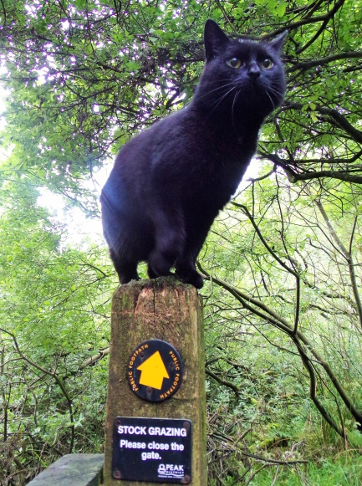
A pleasant circular walk that starts and finishes at Saltswell cottage and takes in open farmland, a river valley, ancient pathways and splendid views. There are modest climbs and some road walking on minor roads. Parts can be boggy in wet weather.
We christened this Black Cat Walk because we were joined by a very friendly black cat who accompanied us for over 2 miles of the walk.
Start at Saltswell and carefully cross the A53 and head towards the shop and pub. Turn right down the minor road between them and look for a stile on your left just after the buildings. Take this past the dilapidated farm building on your left and head straight down into the valley. Head towards the stream at the bottom of the valley and you’ll find a stile that brings you out onto a minor road.
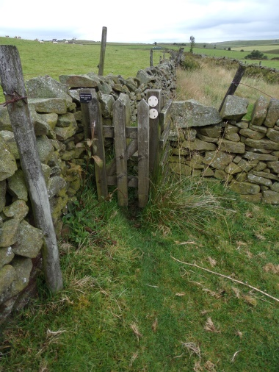
Cross the road and take the path off to your right leading up to the right of the river Dove climbing up with the valley dropping away to your left. Stick to the left side of the fields using the stiles to navigate until you emerge on grazing land that drops to the valley floor. Keep walking forward with a farm cottage on your left. Look for the footpath sign that leads off right over another stile. Follow this path across the fields and you reach a junction where you emerge onto a track with paths and farm tracks heading off in different directions.
You want to head off down the lane on your left – it leads down to a cottage via a cattle grid and a short switchback as you descend towards the cottage. As the road leads to the cottage keep the cottage on your left and follow the wall on your right down to a gate on your right at the same level as the cottage. Head right through the gate and keep to the path with the wall on your left; you’ll meet a track which you need to turn left onto until you very shortly see a track to your left through a stile.
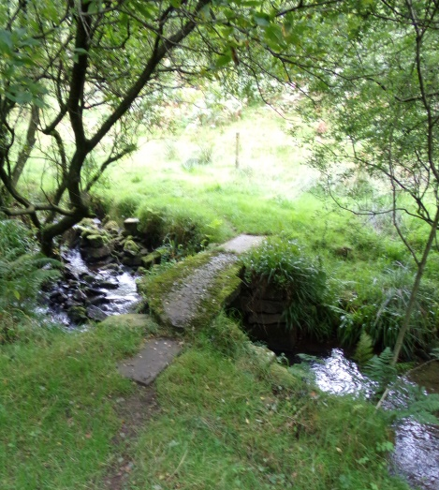
This track leads down to the river through a narrow track bordered on both sides by a stone wall. When we walked it it was very overgrown with bracken but the path was clear to see and we had the cat to help us navigate. After a while the path leads to a steepish descent through a wooded path down to the river on the valley floor. The path is clearly marked and you will pass through a gate at the bottom before crossing the river by a small stone bridge.

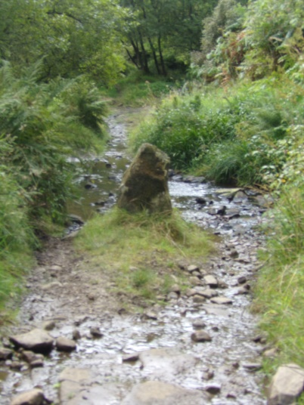
Follow the path up the other bank and bar left to follow the path with the river on your right. The path follows this course descending steeply to cross a tributary and climbing again to follow the same course until you join an old stone path. Turn right through the gate and follow the track to cross the river Dove by the stone bridge (or ford it if you are feeling adventurous).
Across the stream you need to follow the track as it climbs out of the valley, gradually becoming a single track path before emerging onto a minor road with a farm on the right. You need to follow this road up to join a slightly better road at Golling Gate farm. Follow this road uphill until you get to a T junction where it meets the Longnor – Flash road at a small traffic island. Turn right and follow the road towards Flash downhill until you find a footpath on your left. This follows a track (which isn’t very clear at first) around a farm and then hugs the hillside. Follow it into open fields and stay close to this course across the high ground to emerge at a cottage.
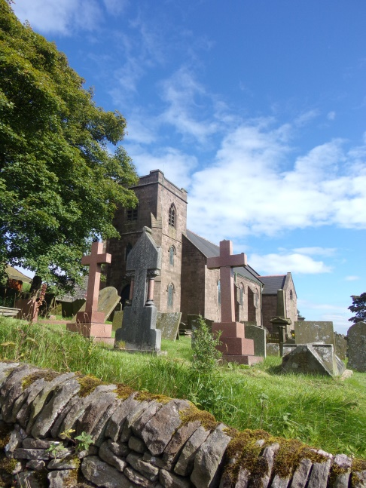
Keep the cottage on your left and follow the track down into the valley floor and up to the A53 main road. Be very careful crossing the road and go through the metal gate ahead for the footpath. Stay to the right of the fields to the Farm. The path leads ahead through the farm and bears left behind the farm buildings to emerge onto a track that you follow right past Flash Church on your right.
You emerge in the village, turn right and follow the road past the old school and village hall until you see Saltswell on your left.

