Panniers Pool Waterfall Walk
Ordinance Survey map OL24 – The Peak District - White Peak Area

This walk starts and finishes at Saltswell and is a great introduction to the area around Flash, taking in ancient pathways, rolling hills, moorlands and stunning scenery including two waterfalls. There is some road walking but they are mostly quiet backroads with very little traffic. There is one very steep decent and a one steep climb up a grassy slope, although there is an alternative if its wet and slippery.
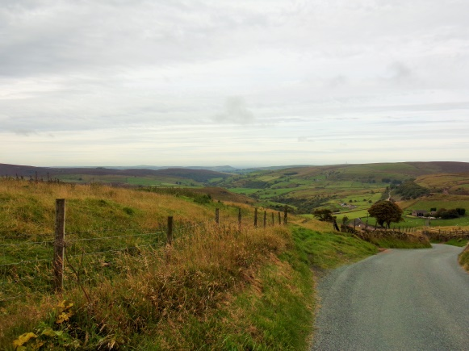
Start from Saltswell and turn right on the road into Flash, passing the village hall and school on your left. In the village keep right ahead keeping the pub to your left and head uphill out of Flash. Follow the road over the crest of the hill and descend until you see a marked path on your right that leads through a narrow field then through a gate and heads downhill to a farm track. Turn right onto the track and after a few yards take a marked path on your left across a field, heading for the sile straight ahead.
After the stile the field drops steeply – keep the farm wall on your left and the path descends steeply through a wooded valley to the river below. This path can be very slippery. Cross the river and head up the opposite bank. There is a small waterfall as the river heads down from the crossing point and into the valley.
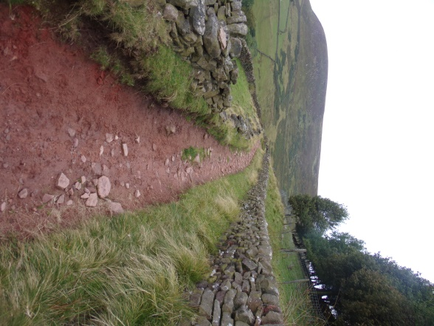
Heading up the opposite bank you need to head straight on, crossing over the stone wall at a gap where the wall that runs parallel with the river and another wall meet. Head off towards a farm keeping to the immediate left of the wall. Just before the farm there is a footpath marked right through a gate, this leads onto a track that leads up a short drive to join a minor track.
Head left on the track and this skirts around Turn Edge – passing in front of another farm via a gate, and gradually narrowing to become a footpath that clings to the side of the hill, slowly going downhill and following the path of the river until you reach Panniers Pool, a crossing point on the river marked by two waterfalls and a stone bridge.

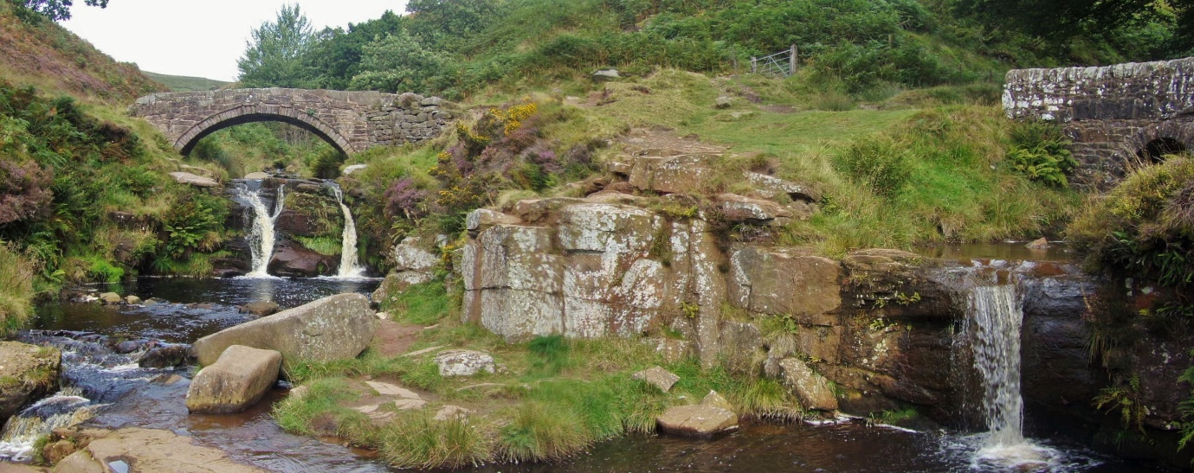
Don’t cross the bridge – instead head right to follow the path on the left bank of the small stream that feeds the smaller waterfall. This rises gently away from Panniers Pool. Stay on the path, until you cross a footbridge, heading over it you come to a point where a road ends at a junction for access to private dwellings.
Opposite is a path leading steeply uphill* which exits the hill onto a track with a cottage on your left. Follow the track away from the building bearing right along the track and the path leads downhill on your left, it wasn’t clearly marked when we did it but you can see where others have walked joining the road where it climbs between two hills up out of the valley. Follow the road.
*If the steep climb is very muddy or you just don’t fancy climbing up a steep slope you can stay on the road and you will re-join the walk here.
Follow the road over the hill, ignore the turnings on your left at some cottages and stay on it as it descends to a junction ignore the right turn to Knotbury and follow the road as it swings left and upwards again.
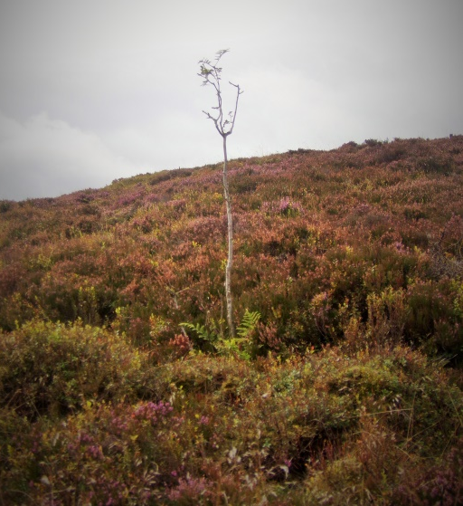
As you reach the highest point keep ahead, ignore the footpath on your right, and the road to your left. The road will descend and you will see the Café and Knights Table pub ahead. Take the footpath on your right rising over moorland and head towards the weather station. Just before you reach it you’ll see a stile to your left, cross it and descend through the small field to the stile opposite. NOTE the property at the foot of this hill where the footpath goes was doing some work to the land and we had to cut right after the stile, following a path around their yard which looked like it was being turned into a 5 a side football pitch. Follow the pitch boundary and you can get onto the access track to the building which is the footpath leading right, through a marked footpath gate, past another property on your right and you join the main A53. Turn right on the narrow path and Saltswell is a few yards ahead on your right.

